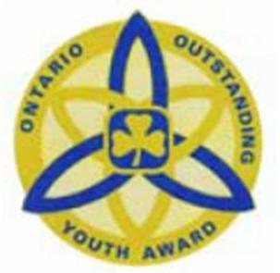
Outstanding Youth Award Nomination

Name of nominee: _______________________________________ iMIS #: ______________
Branch: _____________________________________________________________________
This form is to be filled in by an adult member of Guiding (cannot be a relative of the member).
Two supporting nomination letters are required.

- One is to be from a peer
- One is to be a non-member of Guiding in her community. (i.e. teacher, supervisor, community member, other organization)
- This application will be required to be uploaded as the third supporting letter in Survey Monkey.
The Outstanding Youth Award recognizes and celebrates the accomplishments of Rangers and Pathfinders who exemplify their dedication to Guiding and their community.
The Outstanding Youth Award is presented based on the following criteria:
The nominee:
- Is a registered member of Girl Guides of Canada, Ontario Council, at the Ranger or Pathfinder level
- Displays exceptional leadership qualities within Guiding and in their community at large; enthusiastically brings their personal talents and skills to Guiding
- Has demonstrated qualities of dedicated service to Guiding and their community
- Lives by the ideals of the Guiding Promise and Law; is a positive role model within and outside of Guiding; actively promotes Guiding and its benefits
- Is well respected by their peers, Guiders and other members of the community
- Has contributed significantly and has had a positive impact on the unit and community
Exceptional Leadership
How has the nominee displayed exceptional leadership qualities within Guiding?

How has the nominee displayed exceptional leadership qualities in their community? (e.g. school, community organizations, clubs, other organizations?)

Describe the nominee’s involvement with younger branches within Guiding.

What talent/skills does the nominee bring to Guiding?

Promise & Law
How does the nominee live by the ideals of the Promise and Law?

What does the nominee do to promote Guiding within the Guiding movement and in their community?

